**The Remarkable Raj: Why Britain should be proud of its rule in India**

**IT TOOK the fragile ships five arduous months to navigate the treacherous seas around the Cape of Good Hope and reach the vast sub-continent of India. They returned laden with spices and tea to delight British palates, and cotton and silk to provide clothes for British backs.**

**By:** [**Adrian Lee**](http://www.express.co.uk/search/Adrian+Lee?s=Adrian+Lee&b=1)

**The Daily Express**

**June 22, 2013**

British rule has paved the way for India's *British rule has paved the way for India's economic prosperity according to Dr Kartar Lalvani*

The period of colonial rule, spanning some 200 years, is routinely depicted as the systematic plundering of a nation. The popular view is that the Empire stripped India of its natural resources and gave little in return, leaving the place all but destitute when independence was finally granted in 1947.  
  
Now, however, a new book written by an Anglo-Indian challenges this notion. It asserts that in fact Britain laid the foundations for modern-day India and the prosperity that it enjoys today.  
  
The girders for every bridge, the track for every mile of railway and the vast array of machinery required for India's infrastructure were all carried there by the same ships that helped exploit a land thousands of miles away. The engineers who laid the cornerstones for India's development from Third World nation to burgeoning industrial superpower were British.  
  
"The indisputable fact is that India as a nation as it stands today was originally put together and created by a small, distant island country," says Dr Kartar Lalvani, founder of the vitamins company Vitabiotics and a former Ernst and Young Entrepreneur of the Year, in the book he has spent the past eight years writing, The Making Of India: A Story Of British Enterprise. It comes out later this year.  
  
He adds: "The 'sins' of the Empire have been widely and frequently written about while the other positive side of the imperial coin, of which Britain can be proud and which laid the foundations for modern-day India, has always been overlooked. This is the first book of its kind to recognise Britain's vast contribution to India's social, civil and physical infrastructure provided during two centuries of colonial rule."  
  
THE British administration of India, a country then with a population of 500 million, diverse religions and spread over 17,000 square miles, was "superbly efficient", he argues. Dr Lalvani was born in Karachi, in 1931, where his father was a successful pharmacist and the family lived comfortably. But in 1947 the partition of India forced them to flee to Bombay, where they had to start their lives from scratch. With that background he is better placed than most historians, who have judged India from afar. He claims that India's success as the world's largest democracy, during a period when many other fledgling nations have endured strife, is largely down to imperial rule. It established the framework for India's justice system, civil service, loyal army and efficient police force.  
  
Dr Lalvani, who came to the UK in 1956 to study, believes that both nations benefited from the trade links that were firmly established in the 17th century and continued under the often maligned East India Company, which founded its first trading post in Surat, on the west coast of India, in 1613. Within 40 years it had another 22 bases, supplying the motherland with everything from salt to opium. At the time India, a country of disparate states, had no uniform government and it seemed that France might gain control as it also sought to expand its empire overseas. That prospect was ended by the victory of Robert Clive over French forces at Plassey, in Bengal, in 1757.  
  
It paved the way for the British Raj to rule India for almost two centuries, for the East India Company to thrive and for fortunes to be made by individuals.  
  
There were cases of corruption and greed and cruel reprisals against opponents but Dr Lalviani says: "It is important to note that there is a substantial list on the credit side.  
  
"They include railways, roads, canals, mines, sewers, plantations and the establishment of English law and language.  
  
"Great cities including Bombay, Calcutta and Madras were built and some of the finest universities and museums in India were founded. The first definitive atlas of India was drawn and there were great social reforms, such as the eradication of thugee (violent highway robbery), the banning of the custom of suttee (the burning of widows on the husband's funeral pyre) and female infanticide.  
  
"Perhaps most innovative of all was the bringing together of several different states into one unified India."  
  
Gradually the power of the East India Company was eroded to be replaced by more direct British government of India, leading to more investment. The Indian Army was formed and its top officers trained in new military academies, modelled on Sandhurst.  
  
At the heart of India's development was the expansion of the rail network, originally built to secure the colonial hold, which still prospers.  
  
Within 25 years, 10,000 miles of track were laid joining distant parts of the nation. By independence, 136,000 bridges had been constructed.  
  
Today Indian Railways is the world's largest employer, with a staggering 1.6 million workers on the payroll. By the mid-19th century India had a postal system, the spread of the English language allowed communication between people from different backgrounds, and the arts were thriving.  
  
Wildlife and ancient buildings, such as the Taj Mahal, were protected.  
  
As long ago as 1905 India's first national park was opened, in Assam state, to allow the endangered rhinoceros to flourish unmolested by hunters.

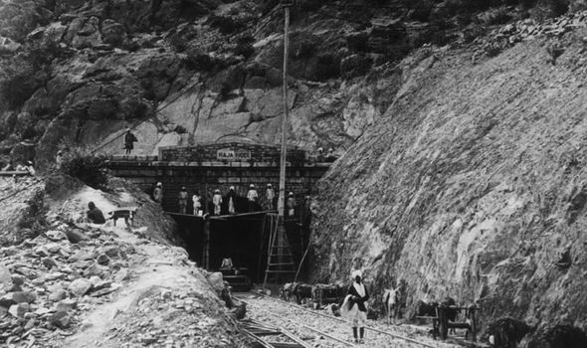An Indian railway tunnel pictured in 1883

*An Indian railway tunnel pictured in 1883*

By 1914, the Indian mining industry, which was built from nothing by the British, was producing nearly 16 million tons of coal a year. Health and life expectancy both improved dramatically, particularly because malaria was tackled and vaccination against smallpox introduced. Dr Lalvani adds: "The 200-year window of British governance was perhaps the only period in a thousand years of Indian history to date when the minorities and people of different religions felt more secure and less discriminated against, with a notable absence of killings, conflicts and persecutions."  
  
As the links between the two countries were established, wealthy young Indians were packed off to Britain to study and returned home well-trained, bristling with new ideas and instilled with a British sense of fair play. The mutual respect among Indians and Britons meant the transition from colonial rule to independence was peaceful.  
  
According to the author, by the time it happened India had a headstart over many former colonies and that was largely thanks to the Raj.  
  
The French, Dutch, Portuguese and Spanish all did much less for their former foreign outposts.  
  
Dr Lalvani believes some of the advantage was squandered by the first Prime Minister of independent India. He claims Jawaharlal Nehru erroneously ran the country along socialist lines, aligning India with the Soviet Union.  
  
Consequently, India missed out on the post-war economic boom and it took many years for the nation to become powerful. Millions of people were destined to live in poverty.  
  
"Nehru betrayed his nation by keeping a misplaced proud distance from the economically successful and friendly Western democracies of the free world and their capital markets," says Dr Lalvani. When India belatedly embraced the global economy, about 20 years ago, it made huge strides. Now, 50 Indians are included on the annual lists of world billionaires - but the wealth has not filtered down to the country's poorest citizens.

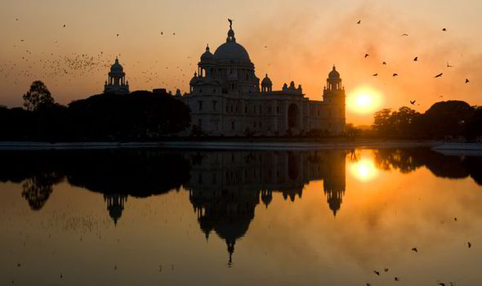

*Dr Lalvani insists India had a headstart over many other formoer colonies*

Despite these problems, India inherited political stability while another legacy of British rule is enduring good relations between the two distant nations.  
  
He says: "Although there were wrongs committed by the British against India, as widely recognised by the British themselves, there was much more that was and remains positive. The sheer audacity and scale of such an endeavour, the courage and enterprise have no parallel in world history."  
  
Dr Lalvani says he despairs that some Indian politicians still insist on attacking its former ruler and disparaging Britain's significant role in the country's development. Instead they should acknowledge the benefits and work to preserve and foster the special relationship between the two nations.  
  
Or, in other words, Dr Lalvani believes that no Indian should today pose the question: "What did the British ever do for us?"